

Name: Muhammad Faisal
Roll no: 2022F-BCS-152

Section: A
Instructor Name: Miss Fozia Khan
Course: Artificial Intelligence Lab (CS - 325L)
Program: (BS) - Computer Science

Lab #08

Activity- 1:
Convert following sentences in to PROLOG FACTS and specify whether they represent RELATIONSHIP or PROPERTY:

Declarative Sentence | PROLOG FACT | RELATIONSHIP or  PROPERTY
SSUET is university | university(ssuet). | % Property
Faheem likes ice-cream | likes(faheem, icecream). | % Relationship
Birds can fly | can_fly(bird). | % Property
Switch is off | off(switch). | % Property
Sara is nephew of Saima | nephew(sara, saima). | % Relationship
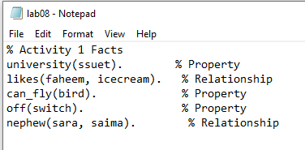

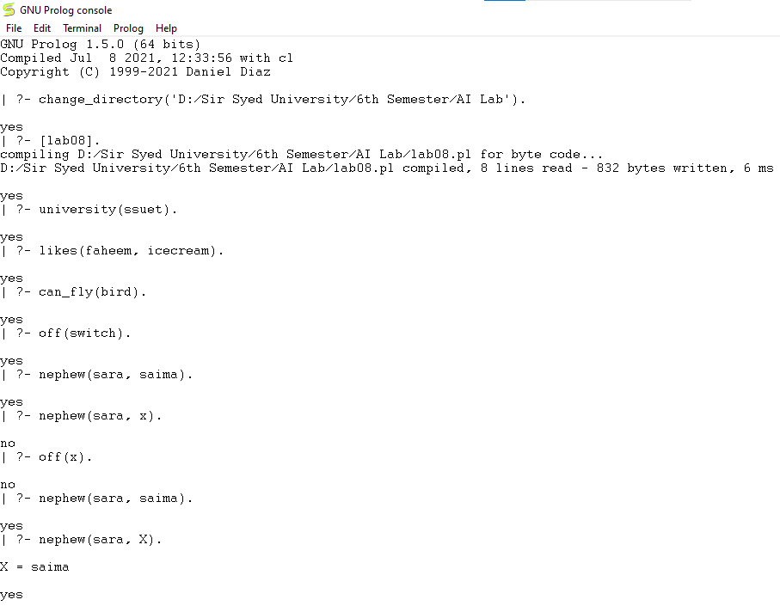

Activity- 2:
Make prolog facts from following sentences and answer the questions by typing queries on prolog.
• Saleem is father of Aslam.
• Dania is mother of Aslam.
• Aslam and Saeed are brothers.
• Faiza is sister of Ali.
• Sana is enemy of Sumra.
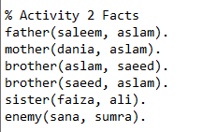

Questions
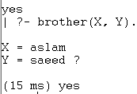
1. List brothers.

2. Who is father of Aslam?
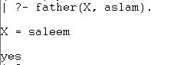

3. Dania is mother of whom?
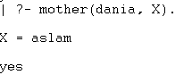

4. Who is brother of Aslam?
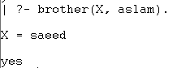

5. Faiza is sister of whom?
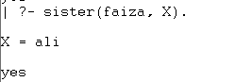

Activity- 3:
Create a file and write below fact and execute this using below question.
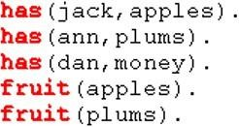

Questions
1. List fruits.
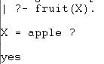

2. Which fruit does Jack have?
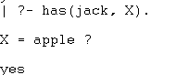

3. Does Dan have something?
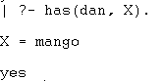

4. Who has apples and who has plums?
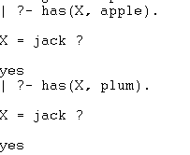

5. Does someone have apples and plums?
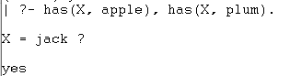

6. Does Dan have fruits?
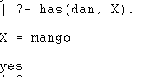

Activity- 4:
Write down the PROLOG Rules for the following sentences:
Declarative Sentences | PROLOG RULES
Person1 is sibling of Person2 if Person3 is parent of Person1 and Person3 is parent of Person2. | sibling(Person1, Person2) :- parent(Person3, Person1), parent(Person3, Person2), Person1 \= Person2.
Person1 is child of Person2 if Person2 is parent of Person1. | child(Person1, Person2) :- parent(Person2, Person1).
It will rain today if clouds are heavy and air pressure is low. | rain_today :- heavy_clouds, low_air_pressure.

Activity- 5:
A person gets good grades if he studies well and is regular in class. Write program in prolog to check whether a given person gets good grade or not?
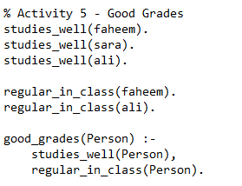

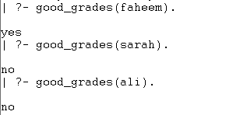

Activity- 6:
Here are some declarative sentences convert them into PROLOG facts and answer following questions.
• Kashif likes music.
• Kashif likes cricket.
• Saba likes chips.
• Saba likes mobile.
• Kashif hates cold drinks.
• Saba hates driving.
• Saba hates parties.
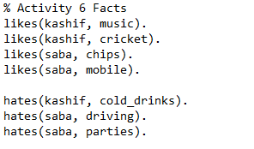

Questions
1. Does Saba like chips?
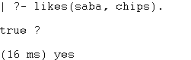

2. Does Kashif hate cricket?
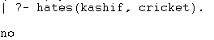

3. Does Kashif like music?
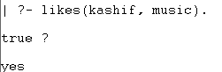

4. What does Kashif like?
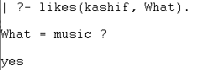

5. What does Saba like?
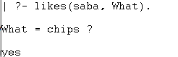

6. Who likes music?
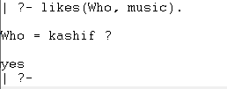

Activity- 7:
There is a cricket team of 5 players; capabilities of each of theplayer are given in following table.
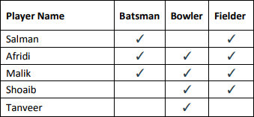

Write the facts from the above table and create the rule for all Rounder and run following goals in PROLOG.
1. Is Afridi all-rounder?
2. Is Shoaib all-rounder?
3. Who are all-rounders in the team?

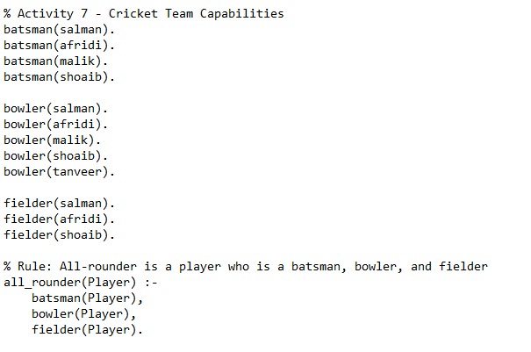

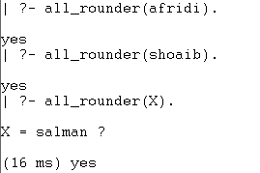

Activity- 8:
Case Study: Family Tree: Consider the following family tree shown in figure below
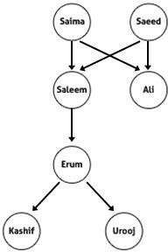

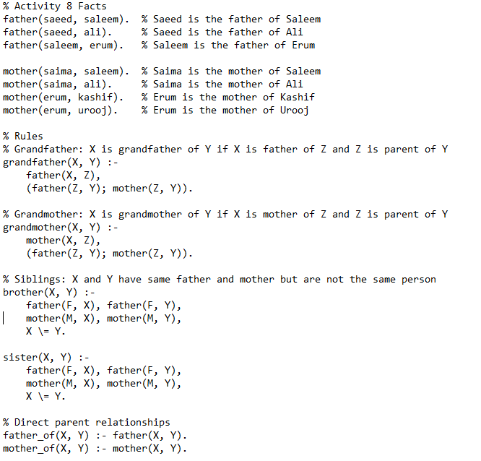
Questions:
1. Is Saleem father of Ali?
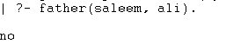

2. Is Kashif brother of Urooj?
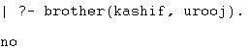

3. Who is father of Kashif?
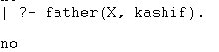

4. Is Erum mother of Urooj?
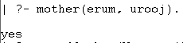

5. Who is grandfather of Urooj?
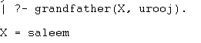
6. Is Salma grandmother of Erum?
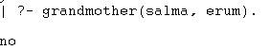

7. Saeed is father of whom?
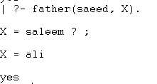

8. Salma is mother of whom?
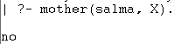

Activity- 9:
Create selection criteria using rules.
1. starter(soup).
2. starter(salad).
3. main_course(rice).
4. main_course(pizza).
5. main_course(burger).
6. desert(custard).
7. desert(ice_cream).
Create rules for hungry, very_hungry and on_diet.
• For hungry: only starter and main course
• For very_hungry starter, main course and desert
• For on_diet it displays only starters.
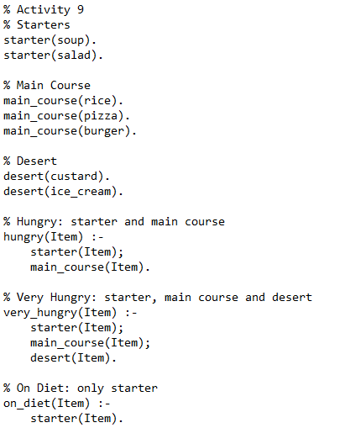



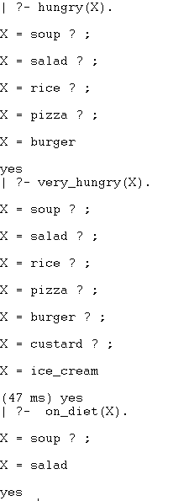

Activity- 10:
Write a program that doubles any number that is taken from user as input.
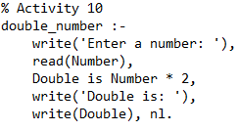

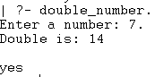

Activity- 11:
Calculate Arithmetic mean of any three numbers.

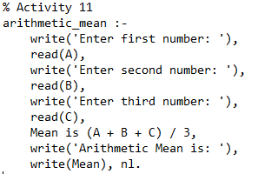

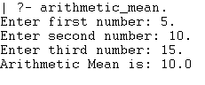
Activity- 12:
Create a basic calculator prolog program for making basic calculations (add, subtract, multiply, divide, average). Use separate goal statements for making each calculation (with constant numeric values).

% Activity 12
% Addition
add :-
write('Enter first number: '), read(A),
write('Enter second number: '), read(B),
Result is A + B,
write('Addition: '), write(Result), nl.

% Subtraction
subtract :-
write('Enter first number: '), read(A),
write('Enter second number: '), read(B),
Result is A - B,
write('Subtraction: '), write(Result), nl.

% Multiplication
multiply :-
write('Enter first number: '), read(A),
write('Enter second number: '), read(B),
Result is A * B,
write('Multiplication: '), write(Result), nl.

% Division
divide :-
write('Enter numerator: '), read(A),
write('Enter denominator: '), read(B),
( B =\= 0
-> Result is A / B,
write('Division: '), write(Result), nl
; write('Error: Division by zero is not allowed.'), nl
).

% Average of three numbers
average :-
write('Enter first number: '), read(A),
write('Enter second number: '), read(B),
write('Enter third number: '), read(C),
Avg is (A + B + C) / 3,
write('Average: '), write(Avg), nl.
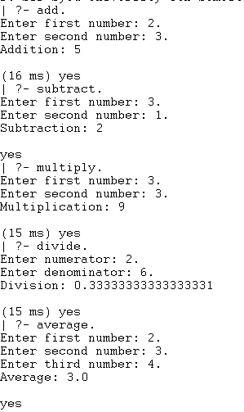

Activity- 13:
Make a calculator program by using write() and read() predicates, for taking numeric input from user and displaying text after program execution.
